Name: Jiwon Yoo

ID: 2485776

Email: jiwonyoo1102@gmail.com

1)

a) Give an example of a syntax (compiler) error.

**#include <iostream**

**using namespace std;**

**int main();**

**{**

**int greeting = “hello”;**

**cout >> greeting >> endl;**

**return;**

**}**

b) Give an example of a logic (runtime) error.

**//write a program that finds average of 3 numbers**

**#include <iostream>**

**Using namespace std;**

**Int main()**

**{**

**int num1, num2, num3;**

**double average;**

**cout << “Enter three numbers.\n”;**

**cin >> num1, num2, num3;**

**average = num1 + num2 + num3 / 3;**

**cout << “average : “ << average << endl;**

**return 0;**

**}**

1. Consider the following code snapshot

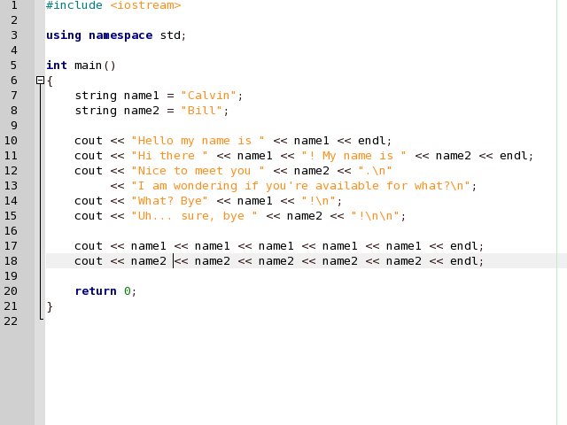



a) What is output? (make sure you're specific)

**: Hello my name is Calvin**

**Hi there Calvin! My name is Bill**

**Nice to meet you Bill.**

**I am wondering if you’re available for what?**

**What? Bye Calvin!**

**Uh…. Sure, bye Bill!**

**CalvinCalvinCalvinCalvinCalvin**

**BillBillBillbillBill**

b) How many statements are there in the main() function?

**ten statements. (everything that ends with a semicolon is a statement).**

c) Identify the code that are variable declaration and initialization statements

(Box these in the code snapshot).

**String name1 = “Calvin”;**

**String name2 = “Bill”**

d) Identify the code that is the program (Circle this in the code snapshot).  
 **Every code is part of the program.**

**Program can’t be run without knowing the library and the body of the function.**

e) Can you figure out one reason how variables are useful in this example?

**The programmer used variable type string to store person’s name, Calvin and Bill.**

**They used somewhat right variable name that explain what’s stored in the variable.**

**But if the programmer already planned out to use name Calvin and Bill, he or she could have used more simple variable names such as calvin and bill or name_cal and name_bill.**

1. Create a program that receives 9 total scores, three for each person, and calculates the average of scores for each quiz. The program should output all values as indicated below. The averages have only two data points, and all numbers are right justified to the center of the QUIZ 1 output.

name Quiz 1 Quiz 2 Quiz 3 Quiz 4

---- ------ ------ ------ ------

John 10 7 10 9

Mary 9 8 10 9

Matthew 8 7 9 10

Average 9.00 7.33 9.66 9.33

1. Write a program that plays the game of Mad Lib. Your program should prompt the user to enter the following strings: For simplicity, each input can only be a max of 10 characters.
   1. A name
   2. Another name
   3. A food
   4. A number between 100 and 120
   5. And Adjective
   6. A color
   7. An animal

After the strings are input, the should be substituted into the story below and output to the console.

Dear [Name],

I am sorry that I am unable to turn in my homework at this time. First, I ate a rotten [Food], which made me turn [Color] and extremely ill. I came down with a fever of [Number 100-200]. Next, my [Adjective] pet [Animal] must have smelled the remains of the [Food] on my homework because he ate it. I am currently rewriting my homework and hope you will accept it late.

Sincerely,

[Name]